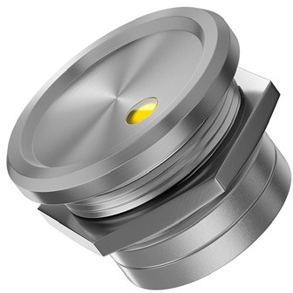
SML2

SML2
22 mm, recessed

SML2 is a fully customizable dot illuminated touch metal piezo switch, developed to serve in the toughest conditions. This product has no mechanical moving parts and is rated at 50 million operations. Additionally, this switch is protected against moisture and dust in accordance with IP68 K / IP69 K. SML2 is ideal for use in demanding applications such as Public Transport, Defence, Food Processing, and more.

Key Characteristics:
- 12 V or 24V LEDs standard (3.3 V and 5 V available)
- Red, green, amber, blue, white or bi-color red/green LEDs
- Aviation Grade Aluminum or Stainless Steel 303 standard (304, 316 optional)
- Anodized Aluminum in silver, black, red, green, blue or gold finishes
- 30 cm cable standard (longer length, connectors, pins or terminal block optional)
- 0.2 A, 24 V standard (1 A, 24 V available)

Electrical Data

Switch Function

Switch Voltage Switch Current
Rated Breaking Capacity Оperating Cycles
Switch Resistance OFF Switch Resistance ON Switch Capacitance Switch On Duration Contact Configuration
N.O. Momentary (N.C. optional) Prolonged, Haptic, Toggle (On/Off), Continuous as well as Programmable, Timer, Slide, Self Diagnostic, and WiFi Enabled optional

0-24 АС/DC

0.2 A standard (up to 1 Amp optional) Power Dissipation < 5 Watt
> 50,000,000

> 20M Ohm

< 5 Ohm

10 pF

Up to 20 sec Free polarity

Mechanical Data

Housing Materials

Actuating Force Non-Illuminated Connection Shock Protection Fastening Torque

Aluminum 6061 T651, Stainless Steel (Type 303, 304 or 316) or Plastic

2-5 Newtons Polycarbonate
22 AWG standard, (pin, tab or terminal blocks optional) IK 10
2.5 Nm

Environmental Data
SML2
Operating Temperature Storage Temperature IP Protection

-20°C to +75°C

-40°C to +125°C IP69 K

*The specifications, descriptions and illustrations indicated in this document are based on current information. All content is subject to modifications and amendments. Users should evaluate the suitability and test each product selected for their own applications.
SML2 | www.barantec.com |
info@barantec.com | Barantech on:

Electrical Diagram

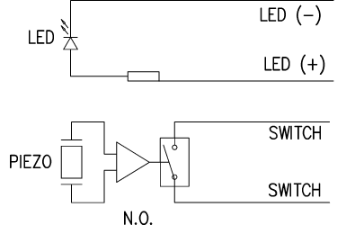

Technical Drawing

